UCCD1004 PROGRAMMING CONCEPTS AND PRACTICES
ASSIGNMENT 2
DUE DATE FOR ASSIGNMENT 2: WEEK 12, SUNDAY BEFORE 11:55PM

Please READ and FOLLOW all the INSTRUCTIONS carefully. You can reuse the code covered in the lectures or from the textbook.
- EQUIPMENT
Hardware: Any suitable machine, as long as it allows for a complete assignment.
Software: Microsoft Visual Studio 2026 Community Edition. The submitted program will be tested by the markers using Visual Studio C++ or other software.
- PROJECT:
This is a GROUP project with THREE members.
- DESCRIPTION OF PROJECT
The assignment focuses on some important aspects of structured programming practices. The aim of this assignment is to provide an opportunity to demonstrate that you have acquired the skills and ability to be proficient in the area of developing C++ application program using modular approach.
- ACADEMIC HONESTY AND COLLABORATION
Cooperation is recommended ONLY in understanding various concepts and system features. However, the actual solution of the assignments, the programming and debugging must be your individual work, except for what you specifically credit to other sources. (Your grade will be based on your own contribution.) For example, copying without attribution any part of someone else’s program is plagiarism, even if you modify it and even if the source is a textbook. You can document the credit to other sources at the start of your program code listing. Offenders will be awarded with ZERO mark for this assignment.
- PENALTY
Penalties such as downgrade or reduction of marks will be given to empty or late submissions unless legitimate reasons are provided.

Descriptions
- It is a group assignment with 3 members (except special cases).

- Given a scenario:
NextFlip is a subscription-based video-on-demand streaming service that distributes both original and licensed films and television shows across various genres. The platform is available internationally and supports multiple languages. Users can add or remove their favourite titles from a personalised list. In addition, merchandise is offered within the platform, allowing users to make purchases using the credit available in their accounts. A system will be developed to integrate and support all of these user functions.
- Each team member is required to choose and develop three/four specific modules as listed below:
Table 1: Sub-functions (sub-modules) of the program
Function (module) | Details
Member 1 (Role: COMBINE CODE) – LOGIN modules
loadUserInfo | A function to read all the registered users' details from "userInfo.txt"
registerNewUser | A function to register new user and save it to "userInfo.txt"
login | A function to validate both the username and password, ensuring secure user login access to the program.
Member 2 (Role: FIX ERRORS) – FAVOURITE modules
loadFavInfo | A function to read the favourite(s) saved in "XXX MDInfo.txt"
addFavList | A function to add favourite to the list and update the "XX MDInfo.txt"
displayFavList | A function to display all the favourite(s) stored in the text file ("XXX MDInfo.txt")
deleteFavList | A function to delete selected favourite in the list and update the "XX MDInfo.txt"
Member 3 (Role: ERROR CHECKING) – MERCHANDISE modules
loadPurchaseInfo | A function to read the credit and merchandise saved in "XXX PurInfo.txt"
addItem | A function to allow all users to easily add credits to their accounts, with corresponding records being updated for transparent transaction tracking. Besides, it also allows all users to add the merchandise to their accounts. All the information is saved (updated) to "XXX PurInfo.txt"
payment | A function to make payment for the merchandise
printReceipt | A function to print the receipt of purchase for the merchandise "XXX Receipt.txt"

- The project consists of at least 11 modules and it is MANDATORY to adhere to the structure outlined in both the provided template and the designated text file for data storage. The group must use the given template and text files to kickstart the program during implementation – no other template structure or text file structure is allowed (modification of text file structure is definitely prohibited!).

- It is crucial to implement the program using the provided coding template and carefully follow the instructions outlined within it. Cover all the topics except Struct (Introduction till String). Marks will be deducted if any of the topics mentioned such as IO, array, function or others are not covered.

- It is important that the flow of the whole program be smooth and work logically like a real program. Each team member is assigned with a specific role:- 1) Combine code, 2) Error checking and, 3) Fix errors. The roles can be rotated among team members (instead of following the assigned roles in Table 1), and it is important to clearly state any role transitions in the report. The responsibilities include:
1. Combine Code: Integrate all modules to form a complete executable program after individual implementation.
2. Error Checking: Inspect for syntax, semantic, and runtime errors.
3. Fix Errors: Address and rectify all identified bugs, ensuring the program operates seamlessly.
- While specific roles are assigned, it is crucial for all members to collaborate both collectively and individually to successfully accomplish all the program modules.

- Creative decorations can be included in the program without interfering with the overall structure.

MORE INSTRUCTIONS

Assignment’s Instructions:
  - This is a group assignment.
  - It is recommended to read this assignment several times before coding.
  - Cover the lecture topics except Struct (Introduction till String).
  - Please take note that your submitted assignment must be within the course scopes. Any submission which is OUT OF THE TOPICS (such as Class, Linked List, Pointer,…) will be awarded with ZERO MARK.

- Report Submission
- The REPORT should include the following items:
 | Item | Description | Tick
i | Cover page | Group Number, name of members, student ID, programme name (e.g., Bachelor of Computer Science), course code and name (to make sure we receive the correct assignment), and email address. (*A sample is provided at the last page) | ☐
ii | Task Division | Specify the modules completed by the members (*A sample is provided at the last page) | ☐
iii | Objective | Objective of the A2 (objective of the program instead of the objective of the subject) | ☐
iv | Pseudocode | 1. Write a pseudocode for the main function (it should not be written in C++ code).  2. Write the pseudocode for the sub-functions outlined in Table 1.  3. Ensure that the pseudocode is sufficiently generalised, making it accessible even to individuals unfamiliar with programming concepts. | ☐
v | Flowchart | 1. Draw flowchart for the main function  2. Draw the flowchart for the sub-functions outlined in Table 1.  3. Ensure that the flowchart is sufficiently generalised, making it accessible even to individuals unfamiliar with programming concepts. | ☐
vi | Test cases | Screenshot of the program output. Please use 2 to 4 different inputs for each member. Each test case should address a particular feature. Note that your test cases should be consistent with your chosen objective. | ☐
vii | Source code | Source code, which is exactly the same as the softcopy submitted to WBLE | ☐

- ZIP the SOFTCOPY of your *.cpp file, *.exe file and the REPORT (.pdf file) together and SUBMIT the .zip file to WBLE before the due date, which is posted on WBLE. The text files are not needed.
- No idea about zip file? Please refer to google or Wikipedia (https://en.wikipedia.org/wiki/ZIP_(file_format)) or 7zip (https://www.7-zip.org/).
- The .exe file is very IMPORTANT and must be included into the zip file.
- Remember to rename all the files (*.zip, *.cpp, *.exe, *.pdf) to your group number as filled in the google sheet, E.g. Group32.exe. NOTE: ONLY ONE member will submit the files.
- No idea about .exe file? Please refer to practical 1.
- The report is not expected to use more than 120 pages. Set single line spacing, font size 11 and choose the font type Times New Roman (Consolas for codes). Exceeding pages will not be reviewed.

- Suggest Grading Scheme
- Correctness of the program according to the provided template.
- Report structure: completeness and quality of presentation of each item.
- Documentation of codes (how easy to understand your codes); However, avoid excessive comments, such as commenting every line of your code.
- Total marks for Assignment 2 are 60 marks (program 45 + report 15) and contributes 15% to the final grade;
- The marking scheme shown below is just a GUIDELINE to develop the complete program and also report;
- The marks may be adjusted according to various circumstances;
- The penalties will be complied as described below:
Suggested Marks
 | Details | Suggested Grading Range
1 | Compilation (able to compile) | 0 - 10
 | Execute (able to execute)
 | Comments (precise comments provided)
 | Input validations (important validations covered)
2 | Modules (according to modules in charge, evaluated individually) | 0 - 18
3 | Effort (decoration, …..) | 0 - 6
4 | Overall (completeness of the program) | 0 - 5
5 | Overall contribution of each member (roles) | 0 - 6
Subtotal marks (program) |  | 45
Subtotal marks (report) |  | 15
Grand Total |  | 60
 | Penalties
1 | Late submission OR wrong submission (re-submission) | 10% deducted per day from total marks that earned
2 | Out of topics  - Class, Linked List, Pointer, Enum, ….  - Other libraries that have not been mentioned in the UCCD1004 learning materials are prohibited UNLESS it is for decoration purposes (put remark to state it clearly)  - E.g. using #include <array> is prohibited | -45
Example Program as a Reference

Member 1: Register new user and login

1. When the user is not registered, they are required to complete the registration process by providing a name, email, username, and password (without spaces) (as illustrated in Figure 1).
The details of the newly registered user will be saved (appended) to the text file “userInfo.txt”, following the format depicted in Figure 2.
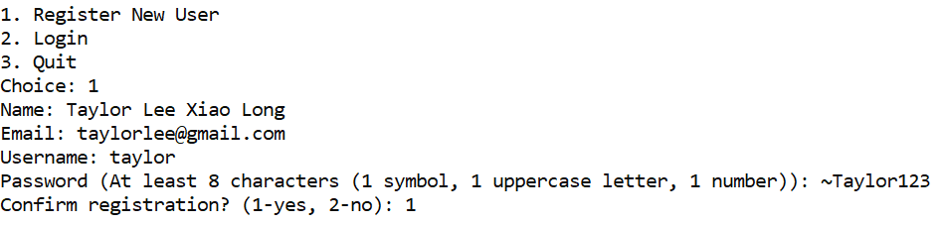
Figure 1: Register a new user

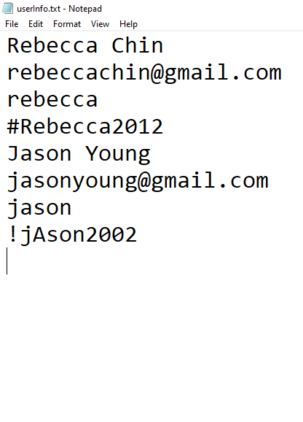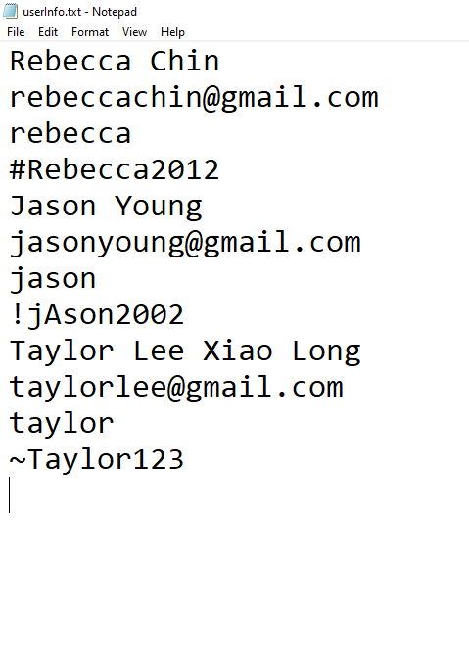
Figure 2: Save the details of the newly registered user into the “userInfo.txt”.
Left: “userInfo.txt” before a new user register, Right: “userInfo.txt” after a new user registered

“userInfo.txt” is essential for storing the user details and its text file structure should adhere to the following format:
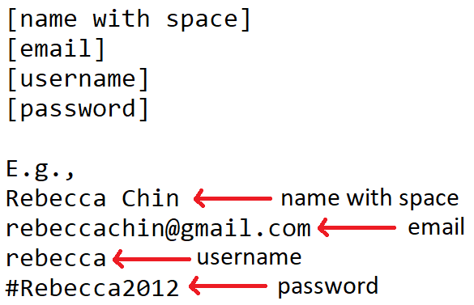
2. The system needs to check the format of the email to make sure the correct email is provided by the user as shown in Figure 3.
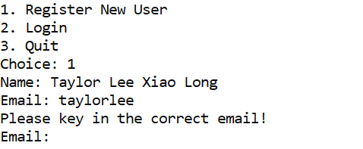
Figure 3: The “@” symbol is missing when the user enters the email address; therefore, a reminder pops up to prompt the user to provide a valid email address.
3. In addition, the system must ensure that users provide a password in the correct format, with at least 8 characters, including one symbol, one uppercase letter, and one number, as shown in Figure 4.
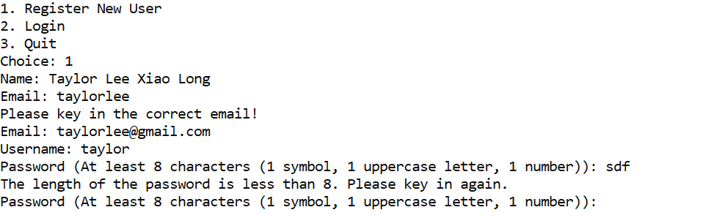
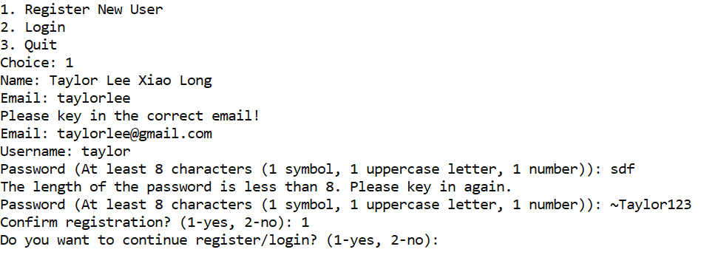
Figure 4: Top: A reminder pops up to prompt the user to provide a valid password; Bottom: Registration is confirmed when all inputs are valid.

4. The user can successfully login when the entered username and password are matched. Upon successful login, the name is prominently displayed on the menu page, as depicted in Figure 5. In cases where the username is not found or the password is incorrect, appropriate messages are displayed, as shown by the example in Figure 6.
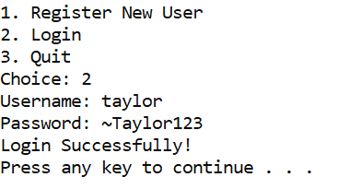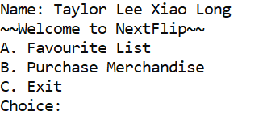
Figure 5: Left: Able to login with the correct username and password, Right: Name is displayed on the menu page.

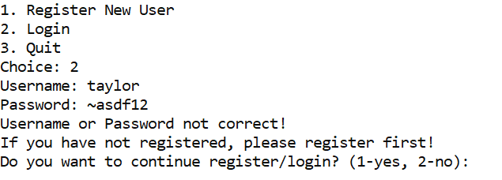
Figure 6: Displays the message when the username or password is not correct

Member 2: Add new favourite, delete favourite and display the favourite(s)

1. User need to select ‘a’ to go into the “Favourite” section as shown in Figure 7.
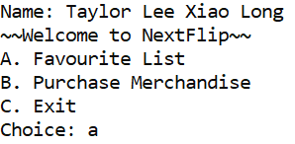
Figure 7: Select ‘a’ to access the “Favourite List” and select ‘b’ to access “Purchase Merchandise.”

2. In favourite section, menu to display favourite, add favourite and delete favourite are displayed as shown in Figure 8. If a new user selects option ‘1’, a message such as “There is no favourite in the list!” will likely be displayed. This occurs when a new user registers and no favourite is added to the list yet. This might also happen when the user deletes all the favourite(s) in the list.
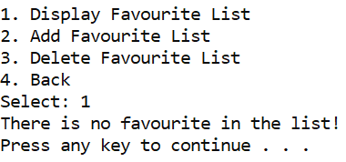
Figure 8: Selection of menu: Select ‘1’ to display all the favourite(s) in the list. “There is no favourite in the list!” is displayed when the favourite is empty.

3. Option ‘2’ is selected to add a new favourite to the list. Details such as category, title, year, language, description, and rating must be entered in order to add the item to the favourite list as shown in Figure 9.
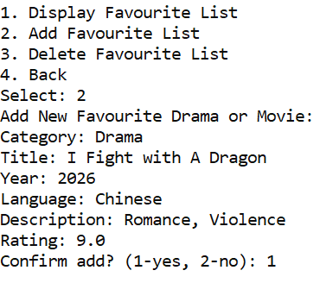
Figure 9: Select ‘2’ and the details of the favourite are keyed in by the user.

Once a new favourite is added into the list, it should be updated in the “XX MDInfo.txt” as shown in Figure 10.
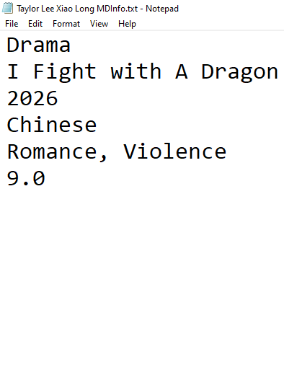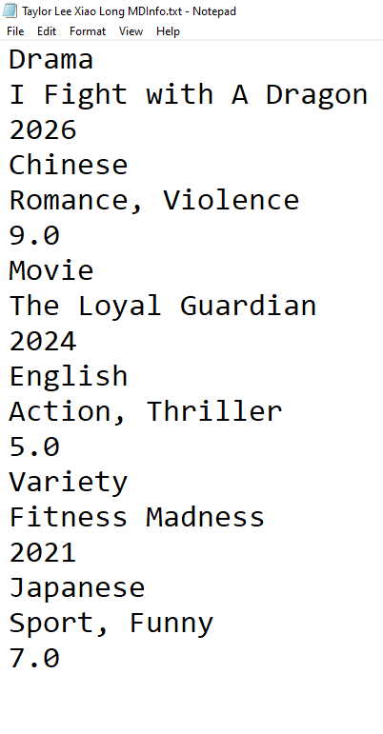
Figure 10: New favourite is added by the user and “XX MDInfo.txt” should be updated accordingly. Left: A new favourite is added and updated in the text file; Right: More than one favourite are added into the list and updated in the text file. All the favourite(s) add by the particular user are stored in “XX MDInfo.txt”.

“XX MDInfo.txt” is essential for storing the favourite keyed in by the respective user and its text file structure should adhere to the following format:
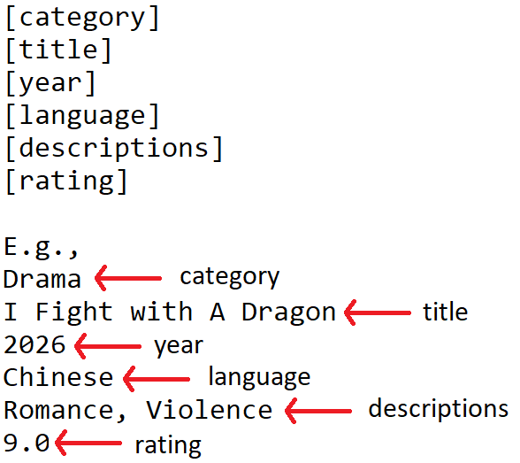

E.g., when Taylor Lee Xiao Long login and adds a Chinese romance (and violence) drama titled “I Fight with a Dragon”, released in 2026 with a rating of 9.0, the details of this drama are recorded in a custom text file named “Taylor Lee Xiao Long MDInfo.txt.” The variable “XX” is dynamically tailored to match the login name.

4. All the favourite(s) will be displayed when the user selects option ‘1’ as shown in Figure 11.
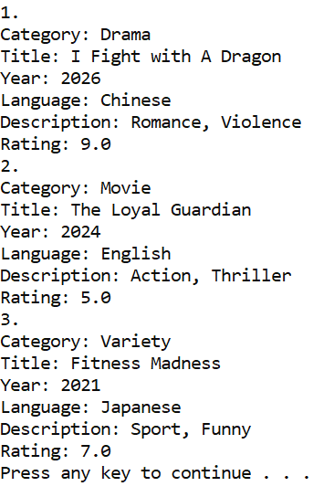
Figure 11: All the favourite(s) are displayed.
5. When the user chooses option ‘3’, the titles of all the favourite(s) are displayed, and the user can select a favourite to delete. The selected favourite is then removed, and the file “XX MDInfo.txt” is updated accordingly by deleting the corresponding entry as shown in Figure 12.

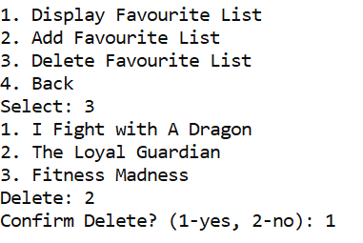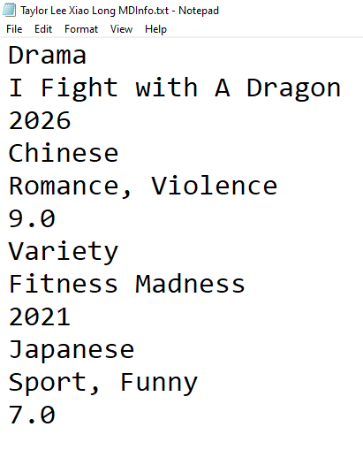

Figure 12: Left: The user selects ‘2’ to delete a favourite titled “The Loyal Guardian”; Right: “The Loyal Guardian” is removed from “XX MDInfo.txt” as it has been selected for deletion.

Member 3: Add credit, add merchandise and make payment
1. User needs to select ‘b’ to go into the “Merchandise” section as shown in Figure 13.
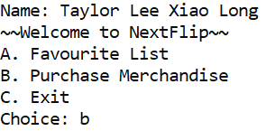
Figure 13: Select ‘a’ to access the “Favourite List” and select ‘b’ to access “Purchase Merchandise.”

2. In the merchandise section, the user can choose to add credit or add merchandise or make a payment as shown in Figure 14. If user select ‘1’, it will show the current credit available in the user account based on the information stored in “XX PurInfo.txt”.

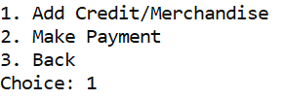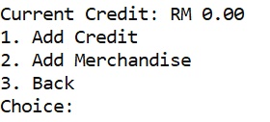
Figure 14: Left: Options to add credit, add merchandise, or make a payment in the merchandise section; Right: The current credit is displayed along with the options to add credit or add merchandise.

If the current user is new, the credit will be zero and there will be no merchandise listed in the “XX PurInfo.txt” as shown in Figure 15.


Figure 15: “XX PurInfo.txt” is used to store the credit and the merchandise available in the user’s account.

3. If “Add Credit” is selected, the user will enter the amount of credit to be added to the account, as shown in Figure 16. This credit is then used to pay for merchandise added to the account.

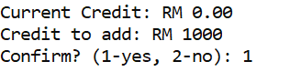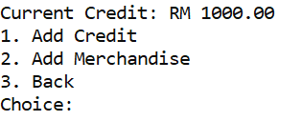
Figure 16: Left: The user chooses to add RM 1000 to the account; Right: The added RM 1000 credit is reflected in the menu once the addition is confirmed.

4. If “Add Merchandise” is selected, the user needs to enter the name of the merchandise, the quantity to purchase, and the price per piece. All previously entered merchandise will be listed whenever the user adds new merchandise to the list, as shown in Figure 17.

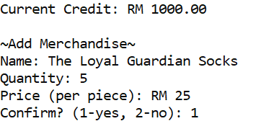
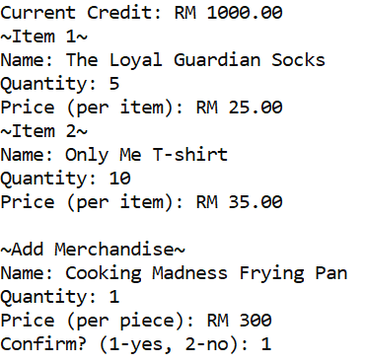
Figure 17: Left: the 1st item is added to the list; Right: All previously entered items are listed whenever the user adds new merchandise.

All the added items (credit and merchandise) are saved to the respective text file “XX PurInfo.txt” as shown in Figure 18.

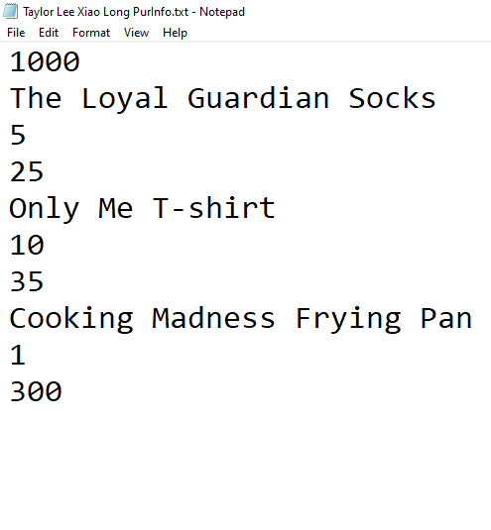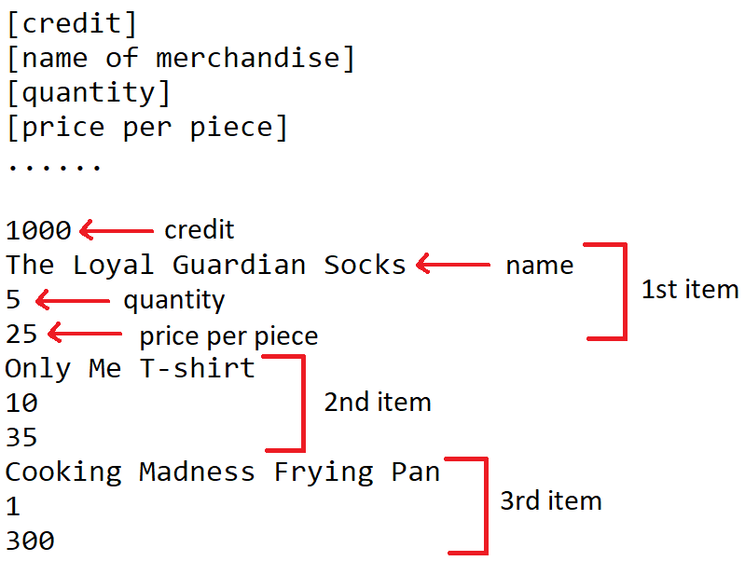
Figure 18: Left: The user’s credit balance and added merchandise are saved in “XX PurInfo.txt”; Right: The storage format for the credit and merchandise. The first line indicates the available credit in the account, followed by the details of the merchandise added by the user.

“XX PurInfo.txt” is essential for storing the available credit and the merchandise added by every respective user, and its file structure must adhere to the format shown in Figure 18. For example, when Taylor Lee Xiao Long logs in and adds RM 1000 in credit along with three different merchandise items, this information is saved in “Taylor Lee Xiao Long PurInfo.txt.”

5. When “Make Payment” is selected, all merchandise items are displayed, and the total price is calculated and shown on the screen as shown in Figure 19.
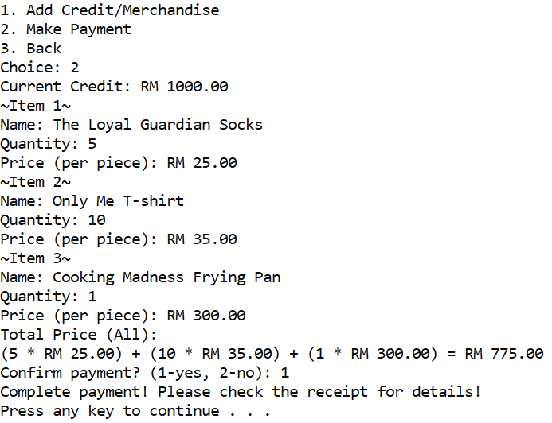
Figure 19: All the merchandise and the total price are displayed when the user decides to make the payment.

6. A receipt, “XX Receipt.txt” will be generated when the payment is made as proof of payment, as shown in Figure 20. The remaining credit, after the purchase deduction, is also indicated on the receipt.
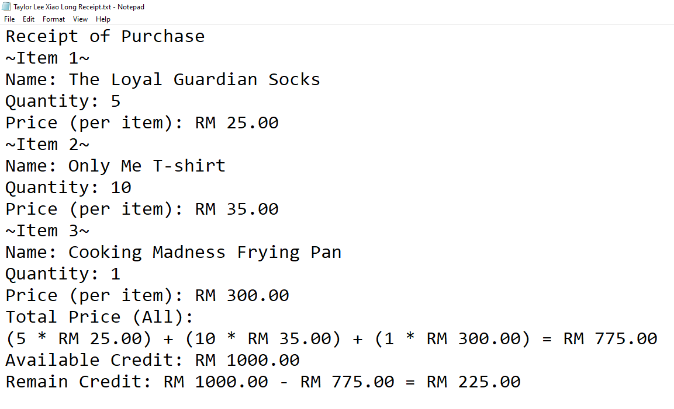
Figure 20: Receipt of the payment is generated when the payment is made.

Please note that “XX PurInfo.txt” should be updated after the payment is completed. The remaining credit must be updated, and the merchandise list should be cleared, as the payment has been processed, as shown in Figure 21.

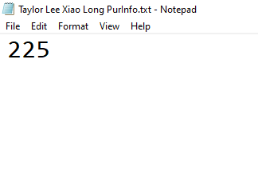
Figure 21: The remaining credit is RM225 after the last payment, and the merchandise list in “XX PurInfo.txt” is now empty.
7. Please take note that payment will be denied if the current credit is insufficient, as shown in Figure 22.
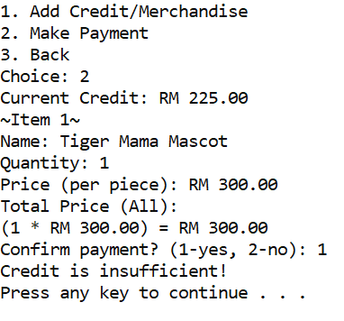
Figure 22: Payment is denied because the current credit is RM225, while the total merchandise cost is RM300. The available credit is insufficient to complete the payment.

UNIVERSITI TUNKU ABDUL RAHMAN

ACADEMIC YEAR 2026/2027

UCCD 1004 PROGRAMMING CONCEPTS AND PRACTICES

ASSIGNMENT 2

Group XX
Name | ID | Programme | UTAR Email

Task Division
 | Name | Role | Modules
1.
2.
3.

